UNIVERSITY OF TRANSPORT HO CHI MINH CITY
INTITUTE OF INFORMATION TECHNOLOGY AND ELECTRICAL, ELECTRONIC ENGINEERING


PROJECT REPORT
Virtual Memory Page Replacement Simulator (FIFO, LRU, OPT)

Subject: Operating System
Course section code: 7480201390613

Group 5

 | Fullname | Student ID
 | - Dương Trọng Nghĩa | 066206008908
 | - Phan Đình Phát | 060206002816
 | - Kim Nhựt Hoàng | 084206006510
 | - Nguyễn Thị Xuân Tuyền | 054306001845
 | - Nguyễn Thanh Tuấn | 051206002660
 | - Đỗ Minh Thuận | 072206012984
Ho Chi Minh City, March, Year 2026
UNIVERSITY OF TRANSPORT HO CHI MINH CITY
INTITUTE OF INFORMATION TECHNOLOGY AND ELECTRICAL, ELECTRONIC ENGINEERING

PROJECT REPORT
Virtual Memory Page Replacement Simulator (FIFO, LRU, OPT)
Subject: Operating System
Course section code: 7480201390613
Lecturer : Mai Ngọc Châu

 | Fullname | Mission | Completion rate
Team 1 | Phan Đình Phat | Algorithm Developer: Implement FIFO, LRU, OPT and calculate page faults/hits. | 50%
 | Nguyễn Thị Xuân Tuyền | Data & File Handler: Read input CSV and export output CSV. | 90%
Team 2 | Nguyễn Thanh Tuấn | GUI Developer: Build GUI, load CSV, and display results. | 100%
Team 3 | Dương Trọng Nghĩa | Tester & Integrator: Test, debug, integrate modules, and record demo video. | 100%
Team 4 | Kim Nhựt Hoàng | Documentation & Presentation: Write report and create slides. | 100%
 | Đỗ Minh Thuận |  | 70%
Duty Roster

Ho Chi Minh City, March, Year 2026

MỤC LỤC

MỤC LỤC 3
TABLE OF CONTENT 4
CHAPTER 1. THEORETICAL BASIS 4
1.1 Virtual Memory Concept 4
1.2 Page Replacement Algorithms 5
CHAPTER 2. ALGORITHM ANALYSIS 5
2.1 FIFO Algorithm 5
2.2 LRU Algorithm 6
2.3 OPT Algorithm 7
CHAPTER 3. COMPARISON OF ALGORITHMS 8
. 3.1 Comparison of Theories and Algorithms between FIFO, LRU, and OPT 8
3.1.1 Explanation of Operation 8
3.1.2 Advantages and Disadvantages 9
Table 3.2 Advantages and Disadvantages 9
3.2 Practical Comparison and Suitability between FIFO, LRU, and OPT 9
3.2.1 Practical Evaluation and Suitability 9
When LRU Performs Better than FIFO and OPT 9
When FIFO Performs Better than LRU and OPT 9
When OPT Performs Better than FIFO and LRU 10
3.2.2 Analysis of Suitability for Each System Type 10
Table 3.3 Suitability of algorithms 10
CHAPTER 4. APPLICATION AND IMPLEMENTATION 10
4.1 Input Data 10
4.2 FIFO Algorithm Result 11
4.3 LRU Algorithm Result 12
4.4 OPT Algorithm Result 12
4.5 Performance Comparison 13
CHAPTER 5. CONCLUSION 14
5.1 Conclusion 14
5.2 Future Development 14

TABLE OF CONTENT
CHAPTER 1. THEORETICAL BASIS
CHAPTER 2. ALGORITHM ANALYSIS
CHAPTER 3. COMPARISON OF ALGORITHMS
CHAPTER 4. APPLICATION AND IMPLEMENTATION
CHAPTER 5. CONCLUSION

LIST OF ABBREVIATIONS

STT | ABBREVIATTION | MEANING
1 | FIFO | First In First Out
2 | LRU | Least Recently Used
3 | OPT | Optimal Page Replacement
4 | VM | Virtual Memory
5 | OS | Operating System
6 | RAM | Random Access Memory
7 | CPU | Central Processing Unit
8 | PF | Page Fault

CHAPTER 1. THEORETICAL BASIS

1.1 Virtual Memory Concept
Virtual memory is an important memory management technique used in modern operating systems. It allows programs to execute even when the physical memory is not large enough to hold all required data. The operating system uses disk space as an extension of RAM and loads only necessary pages into memory.
When a process accesses a page that is not in memory, a page fault occurs. The operating system must then load the required page into memory. If memory frames are full, the system must choose a page to replace. This is done using page replacement algorithms.

1.2 Page Replacement Algorithms
Page replacement algorithms determine which memory page should be replaced when a new page needs to be loaded. The goal is to minimize page faults and improve system performance.
This project focuses on three algorithms:
- FIFO (First In First Out)
- LRU (Least Recently Used)
- OPT (Optimal Page Replacement)
These algorithms are widely used in operating system studies.

CHAPTER 2. ALGORITHM ANALYSIS

2.1 FIFO Algorithm
FIFO is the simplest page replacement algorithm. It replaces the page that has been in memory the longest.
Steps:
- Initialize memory frames
- Insert pages sequentially
- When memory is full, remove oldest page
- Insert new page
- Count page fault
Advantages:
- Easy to implement
- Low overhead
Disadvantages:
- May remove frequently used page
- High page fault rate
For Example:
Table 2.1 FIFO Page Replacement Simulation

Step | Page | Frame 1 | Frame 2 | Frame 3 | Page Fault
1 | 7 | 7 | - | - | YES
2 | 0 | 7 | 0 | - | YES
3 | 1 | 7 | 0 | 1 | YES
4 | 2 | 2 | 0 | 1 | YES
5 | 0 | 2 | 0 | 1 | NO
6 | 3 | 2 | 3 | 1 | YES
7 | 0 | 2 | 3 | 0 | YES
8 | 4 | 4 | 3 | 0 | YES
Note:
FIFO replaces the page that entered memory first. When all frames are full, the oldest page is removed. Total page faults = 7.

2.2 LRU Algorithm
LRU replaces the page that has not been used for the longest period of time.
Steps:
- Track page usage history
- Identify least recently used page
- Replace that page
- Update memory frames
Advantages:
- Better performance than FIFO
- Lower page fault
Disadvantages:
- Requires tracking usage
- More complex implementation
For Example:
Table 2.2 LRU Page Replacement Simulation
Step | Page | Frame 1 | Frame 2 | Frame 3 | Page Fault
1 | 7 | 7 | - | - | YES
2 | 0 | 7 | 0 | - | YES
3 | 1 | 7 | 0 | 1 | YES
4 | 2 | 2 | 0 | 1 | YES
5 | 0 | 2 | 0 | 1 | NO
6 | 3 | 2 | 0 | 3 | YES
7 | 0 | 2 | 0 | 3 | NO
8 | 4 | 4 | 0 | 3 | YES
Note:
LRU replaces the page that has not been used for the longest time. The algorithm tracks recent usage of pages. Total page faults = 6.

2.3 OPT Algorithm
OPT replaces the page that will not be used for the longest time in the future.
Steps:
- Look ahead in reference string
- Determine future usage
- Replace farthest used page
- Count page fault
Advantages:
- Minimum page faults
- Best performance
Disadvantages:
- Not practical in real systems
- Requires future knowledge
For Example:
Table 2.3 OPT Page Replacement Simulation
Step | Page | Frame 1 | Frame 2 | Frame 3 | Page Fault
1 | 7 | 7 | - | - | YES
2 | 0 | 7 | 0 | - | YES
3 | 1 | 7 | 0 | 1 | YES
4 | 2 | 2 | 0 | 1 | YES
5 | 0 | 2 | 0 | 1 | NO
6 | 3 | 2 | 0 | 3 | YES
7 | 0 | 2 | 0 | 3 | YES
8 | 4 | 2 | 4 | 3 | YES

Note:
OPT replaces the page that will not be used for the longest period in the future. This algorithm gives the optimal result. Total page faults = 6.

CHAPTER 3. COMPARISON OF ALGORITHMS

. 3.1 Comparison of Theories and Algorithms between FIFO, LRU, and OPT

3.1.1 Explanation of Operation
FIFO (First In First Out): The page that enters memory first will be replaced first. This algorithm uses a queue structure to track page order. It is simple but may replace frequently used pages.
LRU (Least Recently Used): The page that has not been used for the longest time is replaced. The algorithm tracks page usage history and removes the least recently accessed page.
OPT (Optimal Page Replacement): The page that will not be used for the longest time in the future is replaced. This algorithm provides the optimal solution with minimum page faults.

Table 3.1 Theoretical comparison
Criteria | FIFO | LRU | OPT
Replacement rule | Oldest page replaced | Least recently used page replaced | Page used farthest in future replaced
Page fault | High | Medium | Lowest
Implementation | Simple | Medium complexity | Complex
Performance | Low | Good | Best
Practical use | Used in simple systems | Widely used | Theoretical only
Overhead | Low | Medium | High

3.1.2 Advantages and Disadvantages

Table 3.2 Advantages and Disadvantages
Algorithm | Advantages | Disadvantages
FIFO | Simple implementation | High page fault rate
FIFO | Low overhead | May replace important pages
LRU | Better performance | More complex implementation
LRU | Reduces page faults | Requires tracking usage
OPT | Minimum page faults | Cannot implement in real systems
OPT | Best performance | Requires future knowledge

3.2 Practical Comparison and Suitability between FIFO, LRU, and OPT

3.2.1 Practical Evaluation and Suitability

When LRU Performs Better than FIFO and OPT
Compared to FIFO: LRU performs better because it considers recent page usage. FIFO may replace frequently used pages, causing more page faults. LRU reduces unnecessary replacements and improves memory efficiency.
Compared to OPT: Although OPT gives optimal results, it requires future knowledge. LRU is more practical and widely used in real operating systems.

When FIFO Performs Better than LRU and OPT
FIFO is suitable when system simplicity is required. It has low overhead and is easy to implement. In systems with limited resources, FIFO may be preferred over LRU.

When OPT Performs Better than FIFO and LRU
OPT always produces the minimum number of page faults. It is used as a benchmark to evaluate other algorithms. Although not practical, it provides optimal performance.

3.2.2 Analysis of Suitability for Each System Type

Table 3.3 Suitability of algorithms
System Type | Suitable Algorithm | Explanation
Simple system | FIFO | Easy implementation and low overhead
General OS | LRU | Balanced performance and complexity
Theoretical analysis | OPT | Provides optimal page fault result
Memory constrained system | LRU | Efficient memory utilization
Educational purpose | FIFO,LRU,OPT | Used for algorithm comparison

CHAPTER 4. APPLICATION AND IMPLEMENTATION

4.1 Input Data
The program reads input from a CSV file containing frame size and reference string.
Example input:
Frame size: 3
Reference string:
7, 0, 1, 2, 0, 3, 0, 4, 2, 3, 0, 3, 2, 1, 2, 0, 1, 7, 0, 1
The input is used to simulate FIFO, LRU and OPT algorithms.

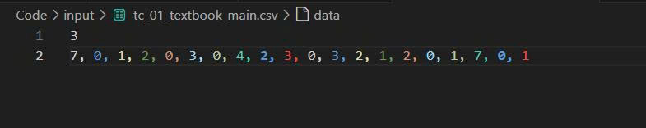

4.2 FIFO Algorithm Result
The FIFO algorithm replaces the oldest page in memory.
Pages are loaded sequentially and the first page inserted is removed first.
From the simulation:
Total Page Requests: 20
Total Page Faults: 15
Page Hits: 5
Hit Ratio: 25%
Fault Ratio: 75%
FIFO produces the highest page fault rate among the three algorithms.
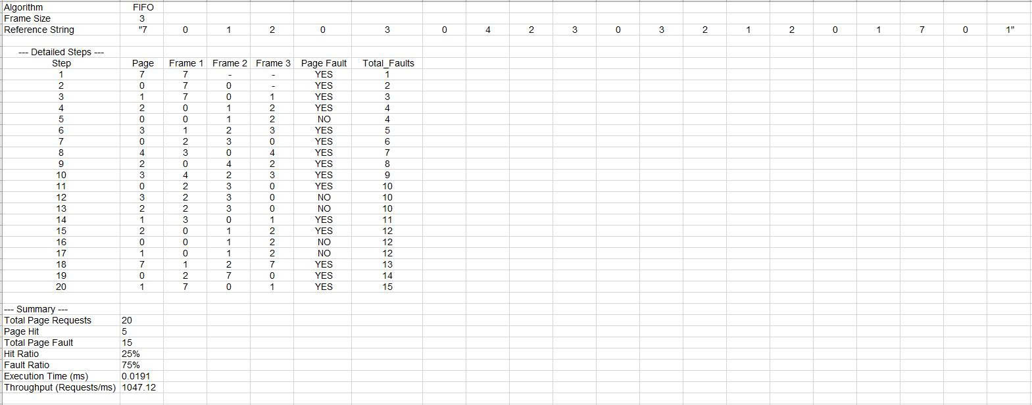

4.3 LRU Algorithm Result
The LRU algorithm replaces the least recently used page.
It tracks memory usage history to reduce page faults.
From the simulation:
Total Page Requests: 20
Total Page Faults: 12
Page Hits: 8
Hit Ratio: 40%
Fault Ratio: 60%
LRU performs better than FIFO by reducing page faults.
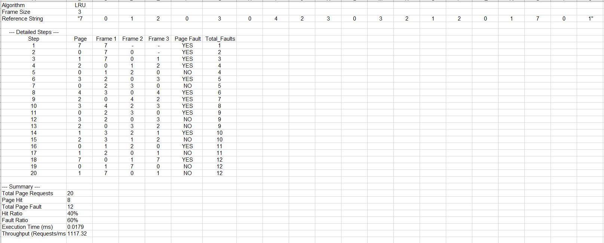

4.4 OPT Algorithm Result
The OPT algorithm replaces the page that will not be used for the longest time in the future.
This algorithm produces the optimal result.
From the simulation:
Total Page Requests: 20
Total Page Faults: 9
Page Hits: 11
Hit Ratio: 55%
Fault Ratio: 45%
OPT gives the best performance.

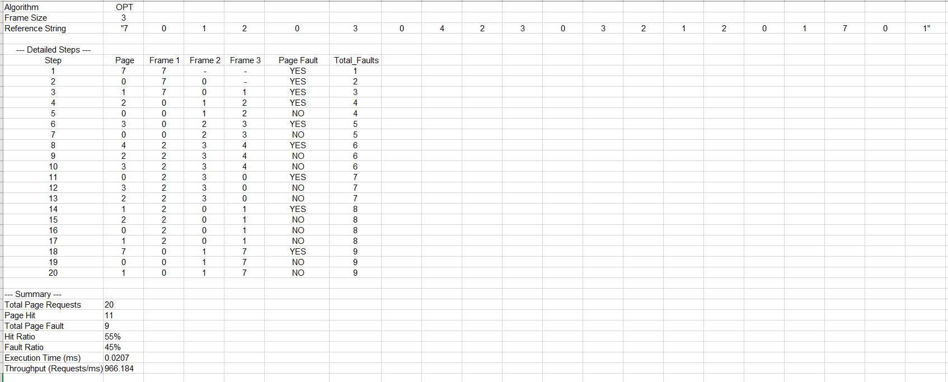

4.5 Performance Comparison
Algorithm comparison based on simulation:
FIFO → 15 page faults
LRU → 12 page faults
OPT → 9 page faults
OPT gives the lowest page faults
LRU performs better than FIFO
FIFO gives the worst performance
Therefore:
OPT > LRU > FIFO

CHAPTER 5. CONCLUSION

5.1 Conclusion
In this project, three page replacement algorithms including FIFO, LRU, and OPT were studied, implemented, and compared. Each algorithm has different characteristics in memory management.

FIFO is the simplest algorithm and easy to implement. However, it may replace frequently used pages, leading to a higher number of page faults. Therefore, FIFO is suitable for simple systems where implementation complexity must be minimized.
LRU improves performance by replacing the least recently used page. This helps reduce page faults and improve memory utilization. LRU provides a good balance between performance and implementation complexity. Because of this, LRU is widely used in modern operating systems.
OPT provides the best performance by replacing the page that will not be used for the longest time in the future. This algorithm produces the minimum number of page faults. However, OPT cannot be implemented in real systems because it requires future knowledge. It is mainly used as a benchmark for comparison.
From the experimental results, OPT gives the best performance, followed by LRU and FIFO. The results show that choosing an appropriate page replacement algorithm significantly improves system performance.

5.2 Future Development
In future work, more page replacement algorithms can be added such as LFU (Least Frequently Used), Second Chance, and Clock algorithm. These algorithms may provide better performance in different scenarios.
The program can also be improved by adding a graphical user interface (GUI) to visualize page replacement steps. This helps users understand algorithm behavior more easily.
Another improvement is allowing users to input custom reference strings and frame sizes. This makes the application more flexible for testing different cases.
Performance measurement can also be extended by analyzing execution time, memory usage, and algorithm efficiency. These enhancements will make the project more complete and practical.

REFERENCES
[1] Operating System Concepts,
A. Silberschatz, P. B. Galvin, G. Gagne,
John Wiley & Sons, 10th Edition, 2018.

[2] Modern Operating Systems,
Andrew S. Tanenbaum, Herbert Bos,
Pearson, 4th Edition, 2015.

[3] Operating Systems: Internals and Design Principles,
William Stallings,
Pearson, 9th Edition, 2018.

[4] GeeksforGeeks,
"Page Replacement Algorithms in Operating Systems",
https://www.geeksforgeeks.org/page-replacement-algorithms-in-operating-systems/

[5] Tutorialspoint,
"Page Replacement Algorithms",
https://www.tutorialspoint.com/operating_system/os_page_replacement_algorithms.htm

APPENDIX A . GROUP ACTIVITY SCHEDULE
1st Meeting ( 4/3/2026 ):
In this first group meeting, our group got to know each other, thereby learning about the abilities and strengths of each member to divide tasks appropriately for each individual. After everyone talked to each other, we decided to elect a group leader. Then the group leader assigned tasks to the members and divided them into smaller teams, thereby promoting work and having better interaction and support for each other.
2nd Meeting ( 10/3/2026):
After the first meeting, the group held the next meeting. In this meeting, the members in charge of the theoretical part reported their progress and raised any problems for the group to resolve together. Then the group leader extended the deadline until the next meeting for the theoretical group to complete so that the coding group could use it to design the program.
3rd Meeting( 17/3/2026):
In this group meeting, the group discussed other algorithms in the topic and selected algorithms for comparison, as well as the coding group began to research and design the program.
4th Meeting(30/3/2026):
In this meeting, the teams completed their tasks and reported back to the team leader. The team leader then recorded and evaluated the members based on their diligence and contribution to the work and began writing the report and design slides.
5th Meeting(7/4/2026):
The group reviews and edits the content together, observing if any content needs to be added or removed. Check for errors and provide feedback to each other to complete the group's topic.

